e-on-arts@hotmail.com

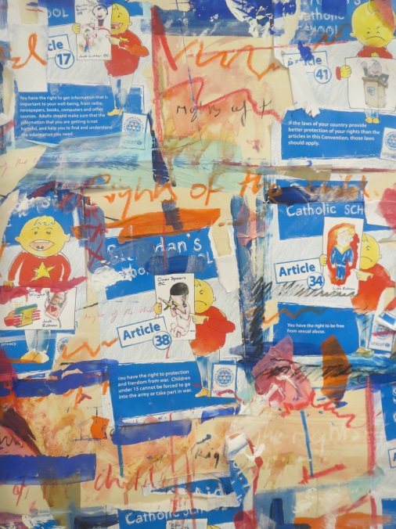
Rights Resecting the child poster and 42 individual door plates.
Students produced graphic work to illustrate the 42 Unicef recommendations. These were made into a large student based installation, while the individual rules were made into doorplates and displayed throughout the school.
Clients/funders/supporters: St. Aidan’s Catholic Academy.
Group: students.

Support the school application to Unicef for a school accredited award.
Introduce rights respecting the child, (Unicef initiative) through a series of workshops and practical graphics/ theoretical problems.
Introduce creative spaces to the school environs as a didactic and decorative resource.
Promote communication and team work.
Provide access to the arts and encourage creative activity.
Engage new audiences with artistic activity.
Teach graphic design elements of pictographs and text, layout and colour.
Produce high quality work for display.

If you require further information about this work, please contact
e-on-arts@hotmail.com or ring Ian MOB: 07982892262

